**Lab - Creating a Custom Microsoft Management Console (MMC)**

**Overview**

One of the great features of the Microsoft Management Console (MMC) is its flexibility in creating our own custom console.

Having a custom Microsoft management console (MMC) places all the tools you need at your fingertips and provides a convenient method for managing Windows Servers and their services. An MMC is a single “dashboard” from which to manage Active Directory, Group Policy, DNS, DHCP, WSUS, WDS, and other services providing speed and simplicity.

1. Login to your Server 2012 full install GUI as Administrator

2. Click the Start button and in the Search box type MMC and press ENTER

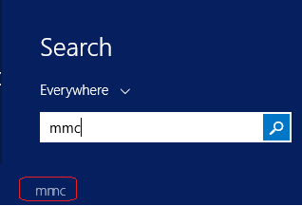

3. Choose Add/Remove Snap-in from File Menu

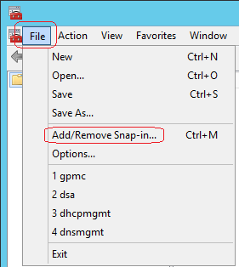

4. Select **Active Directory Users and Computers** and click Add

5. Click OK to close the Add/Remove Snap-in Dialog Box

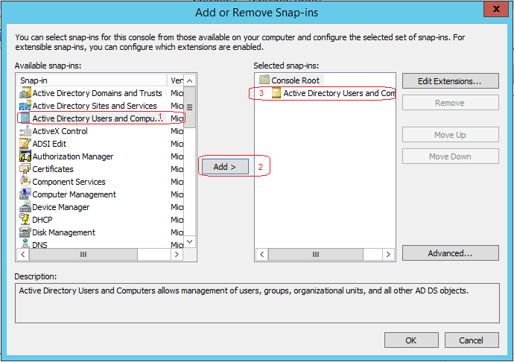

Close the Add or Remove Snap-ins.

6. Click Start Button in the Search box and type cmd

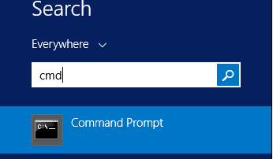

7. At the command prompt type **regsvr32 schmmgmt** and press ENTER

8. Click OK and close the cmd.

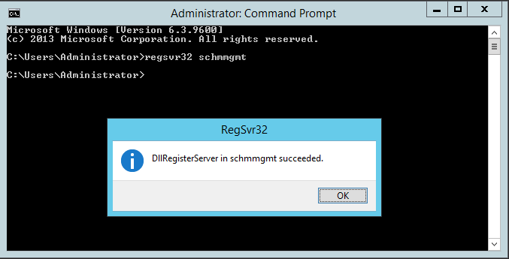

9. Return to the MMC

10. Add the Active Directory Schema Snap-In

11. Add the Computer Management Snap-In and direct it to Local Computer

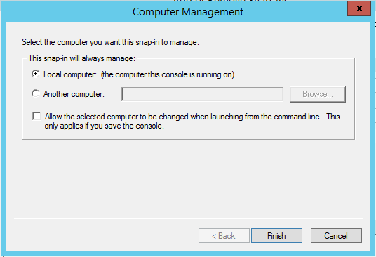

12. Click on Finish

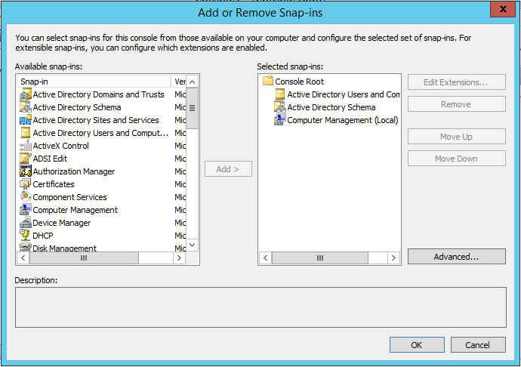

13. Click on OK to close Add/Remove Snap-In

14. Choose Save from the File and save menu and save the console to the desktop with the name

Admin.msc

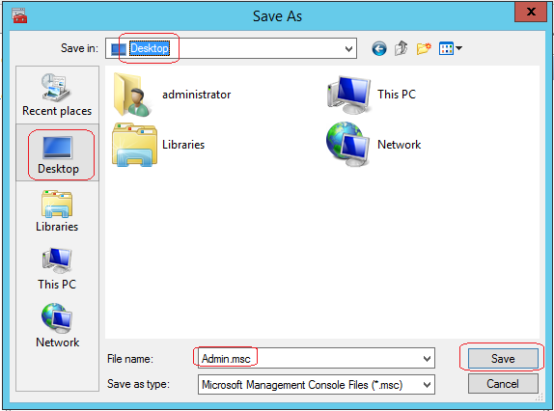

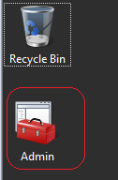

15. Close the console

**Add a Snap-in to an MMC**

1. Open the Admin.msc

2. Choose Add/Remove Snap-in from the File Menu

3. Add the Event Viewer and direct it to the Local Computer

4. Click OK to close the Add/Remove Snap-In

5. Save and close the console

**Manage the Snap-ins of an MMC**

1. Open the Admin.msc

2. Choose Add/Remove Snap-ins from the File Menu

3. Select Event Viewer from the list of Selected snap-ins

4. Click Move Up button

5. Select Active Directory Schema

6. Click Remove Button

7. Select Computer Management

8. Click Edit Extensions

9. Select Enable Only Selected Extensions

10. Deselect Event Viewer

11. Click OK to close the Extensions for Computer Management

12. Click OK to close the Add/Remove Snap-ins Dialog box

13. Save and Close the console

**Prepare a Console for Distribution to Users**

1. Open Admin.msc

2. Choose Options from the File Menu

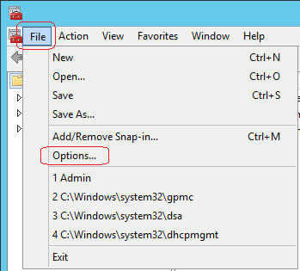

3. In the Console Mode drop-down list, choose User Mode-Full Access

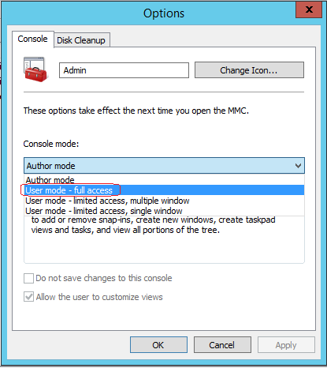

4. Click OK

5. Save and close the console

6. Open the console by double-clicking it

7. Click the File menu

a. There is not an Add/Remove Snap-ins option

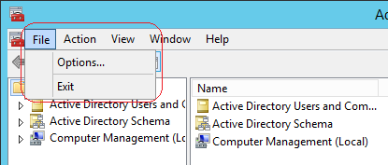

8. Close the console

9. Right-Click the console and choose Author

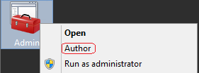

10. Click the File Menu

a. Add/Remove Snap-ins option appears

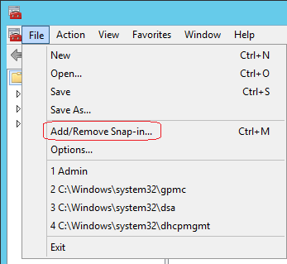

11. Close the Console

End of Lab!